## **Objectives**

* Explain React events
* Explain about event handlers
* Define Synthetic event
* Identify React event naming convention

In this hands-on lab, you will learn how to:

* Implement Event handling concept in React applications
* Use this keyword
* Use synthetic event

## **Prerequisites**

The following is required to complete this hands-on lab:

* Node.js
* NPM
* Visual Studio Code

## **Notes**

Estimated time to complete this lab: **90 minutes.**

Create a React Application “eventexamplesapp” to handle various events of the form elements in HTML.

1. Create “Increment” button to increase the value of the counter and “Decrement” button to decrease the value of the counter. The “Increase” button should invoke multiple methods.
   1. To increment the value
   2. Say Hello followed by a static message.

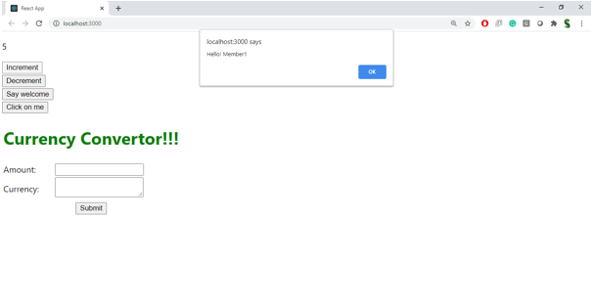

1. Create a button “Say Welcome” which invokes the function which takes “welcome” as an argument.

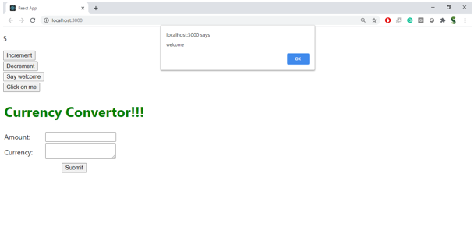

1. Create a button which invokes synthetic event “OnPress” which display “I was clicked”

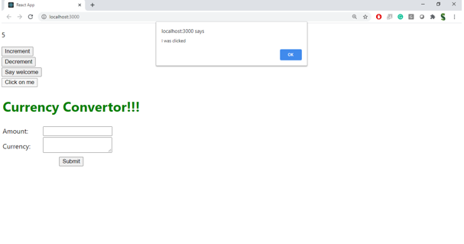

Create a “CurrencyConvertor” component which will convert the Indian Rupees to Euro when the Convert button is clicked.

Handle the Click event of the button to invoke the handleSubmit event and handle the conversion of the euro to rupees.

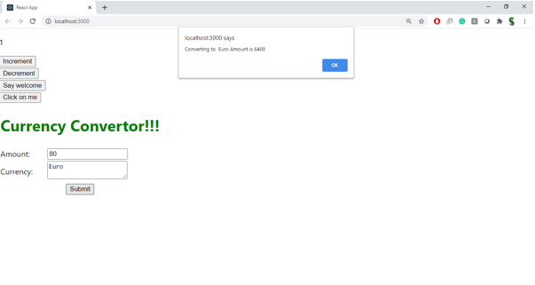

**Solution :**

1. Create the React App

Open your terminal or command prompt and run**:**

npx create-react-app eventexamplesapp

cd eventexamplesapp

code .

**2. Component: CounterEvents.js**

**Create & handle multiple events**

Create a new folder inside src called components and add a file CounterEvents.js:

import React, { useState } from 'react';

function CounterEvents() {

const [count, setCount] = useState(0);

const increment = () => {

setCount(prev => prev + 1);

};

const sayHello = () => {

console.log("Hello! This is an increment action.");

};

const handleIncrement = () => {

increment();

sayHello();

};

const decrement = () => {

setCount(prev => prev - 1);

};

const sayWelcome = (message) => {

alert(message);

};

const handleClick = () => {

alert("I was clicked");

};

return (

<div style={{ border: "1px solid black", padding: "20px", marginBottom: "20px" }}>

<h2>Counter: {count}</h2>

<button onClick={handleIncrement}>Increase</button>

<button onClick={decrement}>Decrease</button>

<br /><br />

<button onClick={() => sayWelcome("Welcome!")}>Say Welcome</button>

<br /><br />

<button onClick={handleClick}>Click Me</button>

</div>

);

}

export default CounterEvents;

**3. Component: CurrencyConvertor.js**

Create another file in components folder: CurrencyConvertor.js

import React, { useState } from 'react';

function CurrencyConvertor() {

const [rupees, setRupees] = useState('');

const [euros, setEuros] = useState('');

const handleSubmit = (e) => {

e.preventDefault();

const conversionRate = 0.011; // 1 INR = 0.011 Euro (example rate)

setEuros((rupees * conversionRate).toFixed(2));

};

return (

<div style={{ border: "1px solid black", padding: "20px" }}>

<h2>Currency Converter</h2>

<form onSubmit={handleSubmit}>

<label>

Enter amount in ₹ INR:

<input

type="number"

value={rupees}

onChange={(e) => setRupees(e.target.value)}

/>

</label>

<button type="submit">Convert</button>

</form>

{euros && (

<p>💶 EUR: <strong>{euros}</strong></p>

)}

</div>

);

}

export default CurrencyConvertor;

**4. Update App.js**

Edit the default App.js to use your two components:

import React from 'react';

import './App.css';

import CounterEvents from './components/CounterEvents';

import CurrencyConvertor from './components/CurrencyConvertor';

function App() {

return (

<div className="App">

<h1>🎯 Event Examples App</h1>

<CounterEvents />

<CurrencyConvertor />

</div>

);

}

export default App;

4.Run the App:

npm start